Humpty Dumpty Hates Butter

Serves 1

Ingredients: 1 egg, 2 tablespoons (28.6g) of butter

Instructions:
- Put the stove on high and place a frying pan on it
- Add the butter into a microwave-safe cup
- Melt butter in the microwave for 30 seconds per tablespoon until there are no solids
- Remove cup from microwave
- Crack an egg into the cup with the butter
- Whisk until a light foam starts to form on the sides of the cup
- Pour the contents of the cup onto the preheated pan
- Stir the egg until no liquid yolk is seen
- (optional) Strain out the butter from the cooked egg
- Serve the egg and enjoy

In this experiment, I used different amounts of butter in an attempt to create fluffier eggs. But in my results It seems that the eggs actually get dense, but the egg yolk seems to separate into smaller and smaller chunks. For example, with no butter the egg seemed to cook into one solid puck, but with one stick of butter, the cooked egg become stringy and gooey. 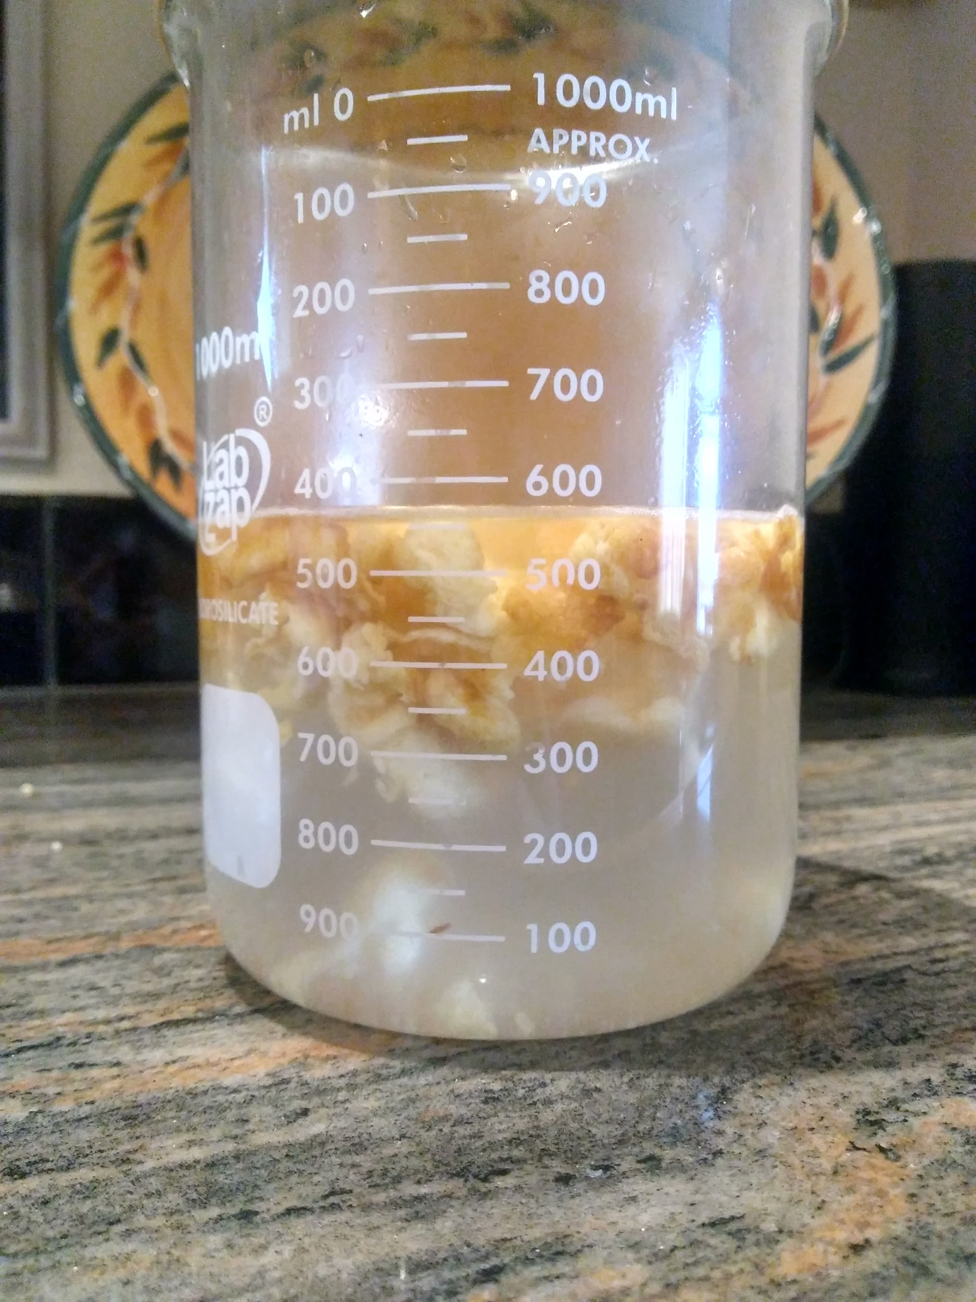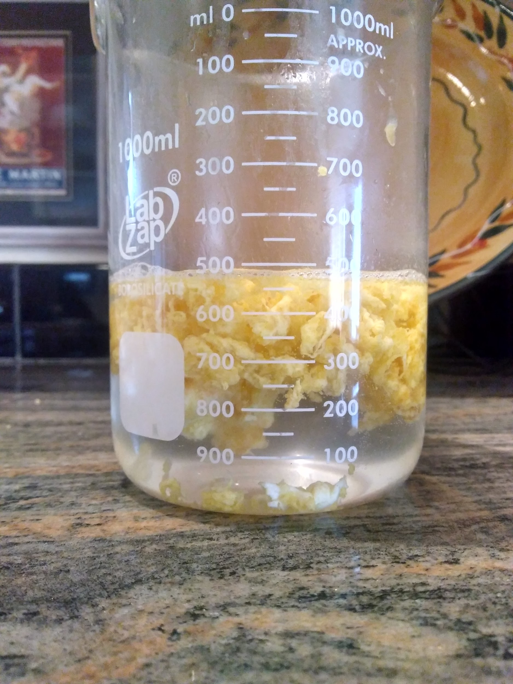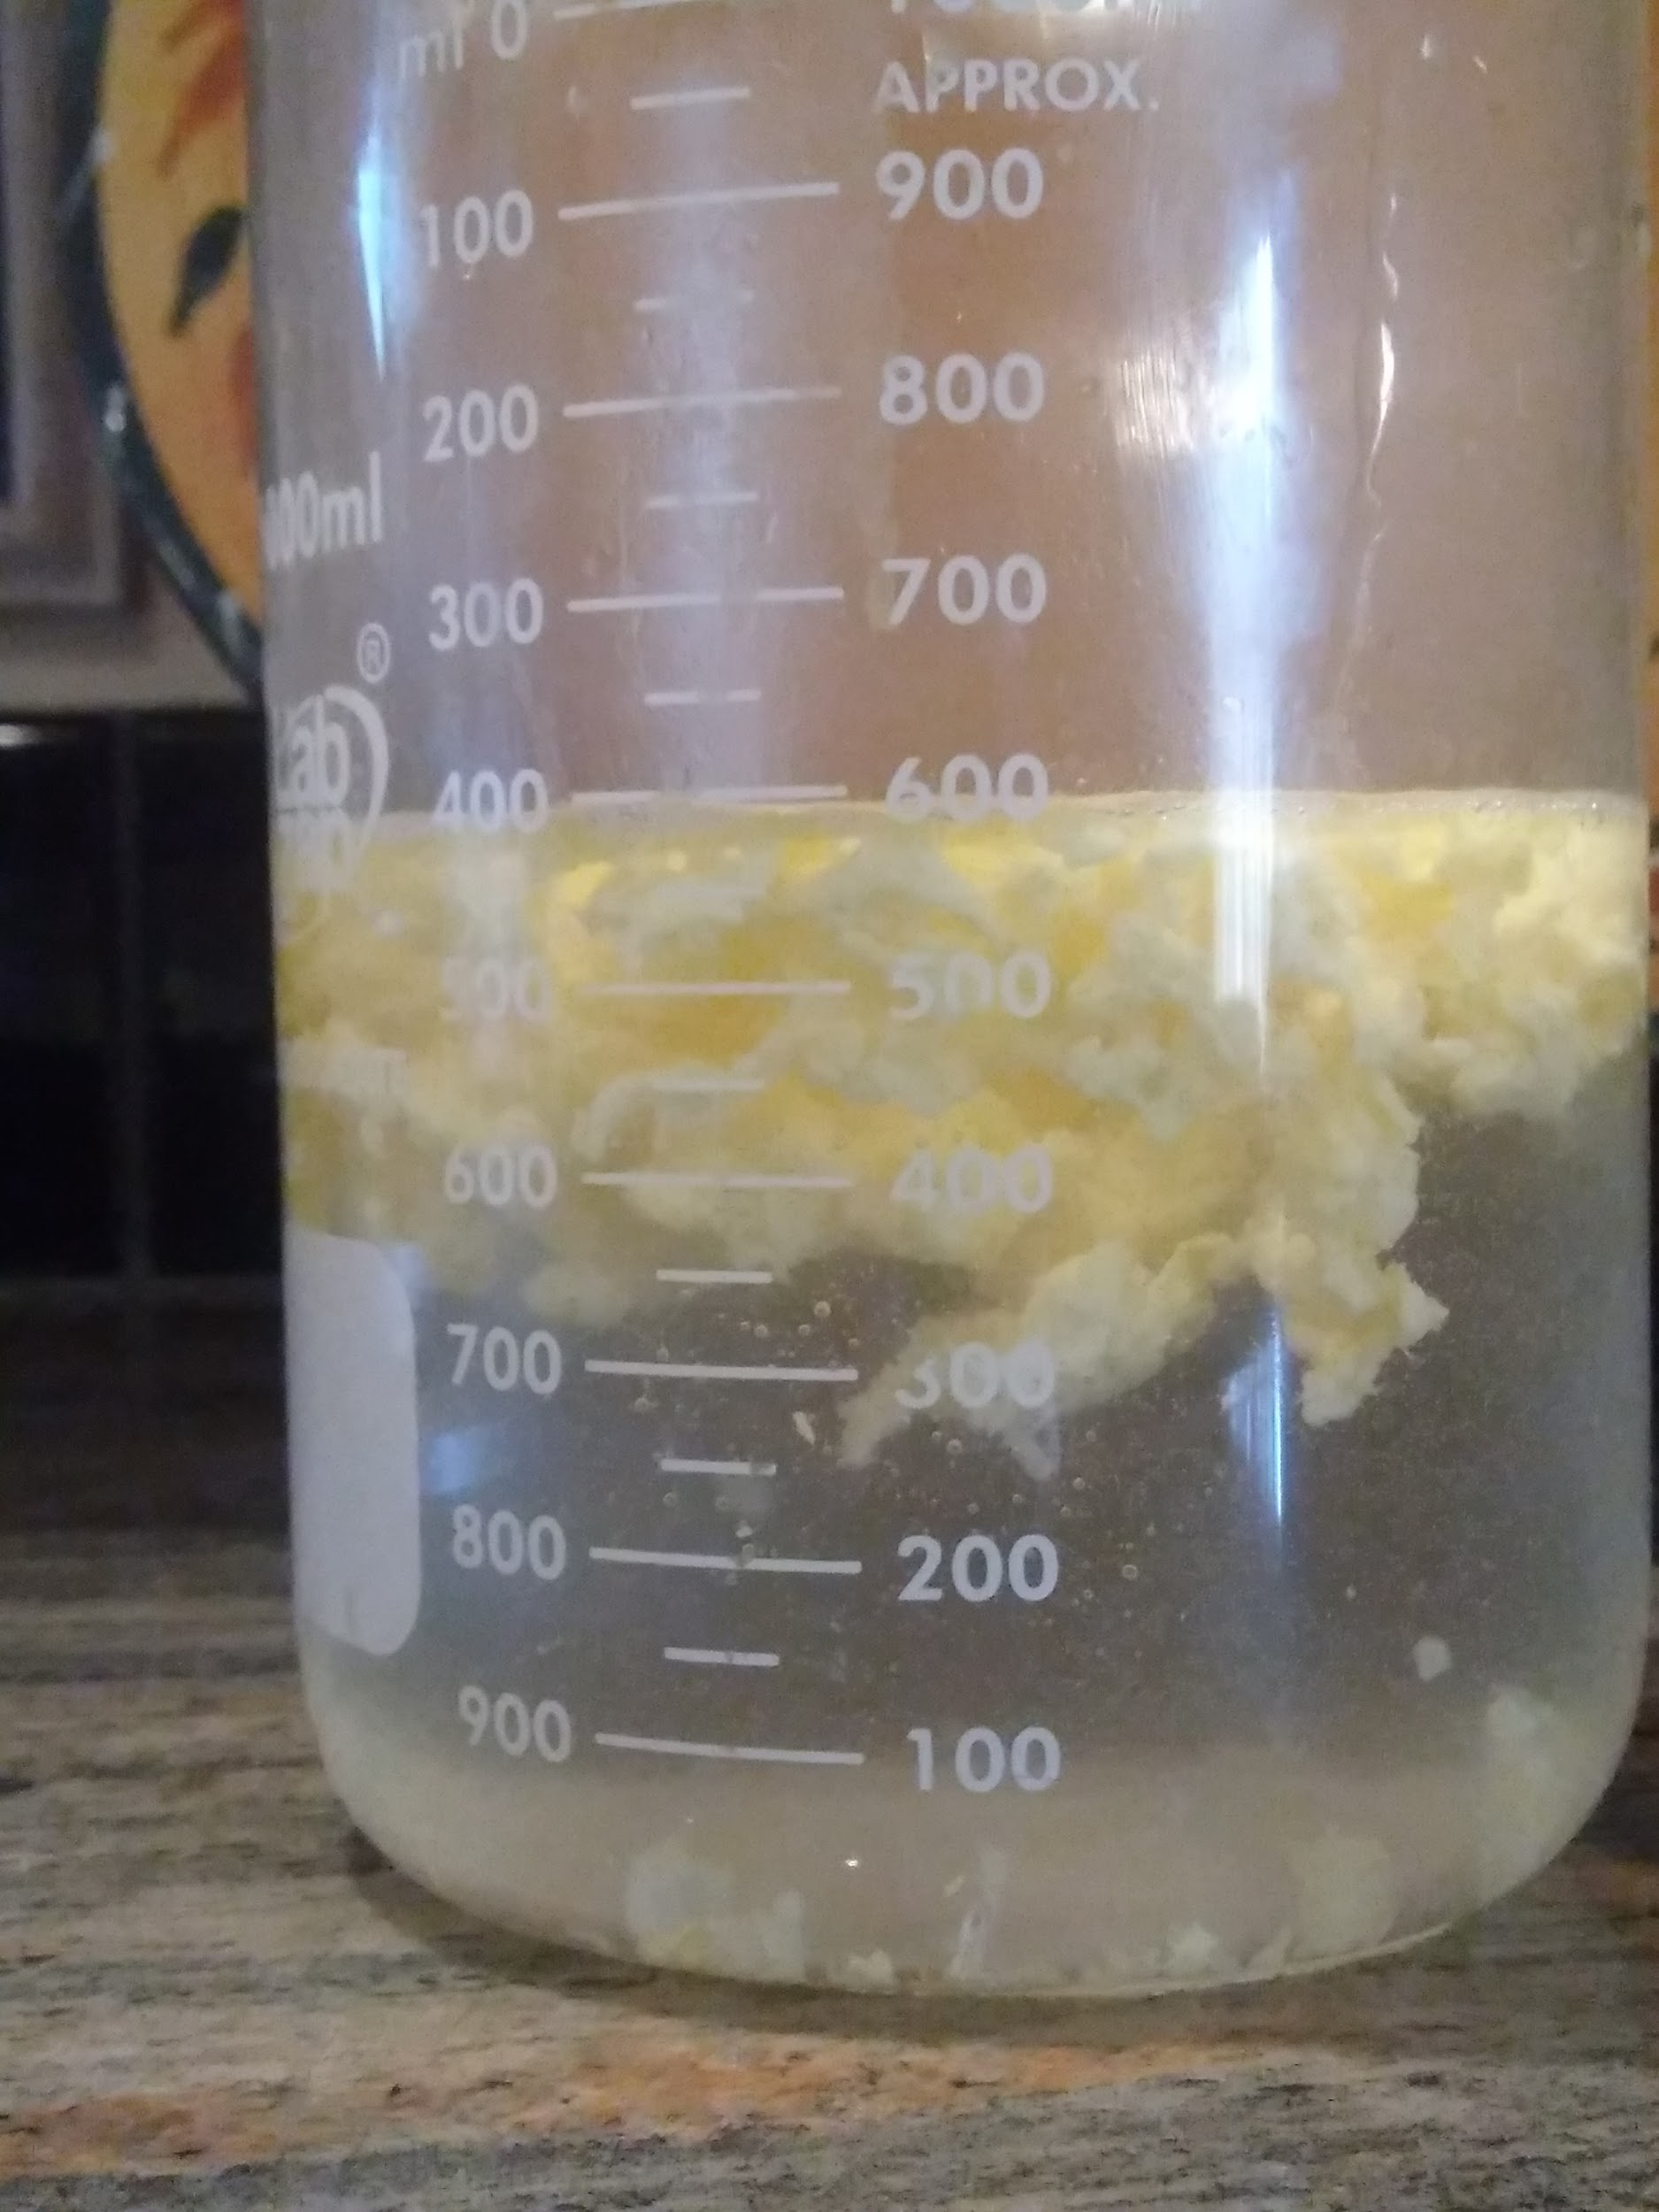
2 tablespoons (28.6g) 4 tablespoons (57.2g) 6 tablespoons (85.8g)

Amount of butter Time to cook Mass Volume Total Density
No butter 0:13 42g 50ml 0.84
1tsp 0:44 49g 50ml 0.98
2tsp 1:20 50g 50ml 1
3tsp 1:31 61g 50ml 1.22
4tsp 1:39 66g 50ml 1.32
5tsp 1:34 66g 50ml 1.32
6tsp 1:36 63g 50ml 1.26
7tsp 1:40 60g 50ml 1.2
One stick 1:56 59g 50ml 1.18

But why do eggs turn into a solid, but not a gas? It has to do with the proteins within the yolk.
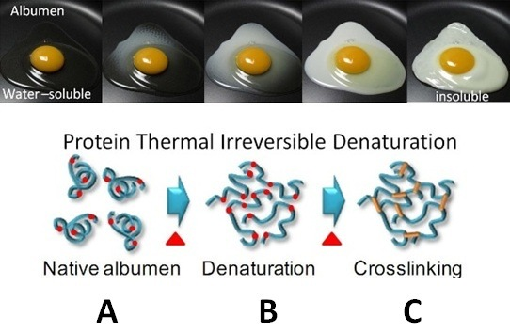

In the picture above the proteins in the egg whites go through a denaturation process. Starting from a native albumen when the proteins are tangled individually, the egg heats up, the proteins start to untangle, then they bond together through crosslinking. The butter seemed to effect the cross linking of the proteins and make the process slower.

But why choose this dish to experiment on? My constant fascination and consumption of eggs has driven me to do this project efficiently. It was really interesting to see the results of my experiment prove my hypothesis wrong. And I hope you can take this information to your use!

